The Communication Trust
The Communication Trust is a coalition of 50 voluntary and community organisations with expertise in speech, language and communication. They harness collective expertise to enable the children’s workforce and commissioners to support all children and young people’s communication skills, particularly those with speech, language and communication needs (SLCN).
http://www.thecommunicationtrust.org.uk/

Talk Halton

This provides guidance and information to support children and young people on their language journey
https://www3.halton.gov.uk/Pages/EducationandFamilies/FamiliesInformationService/talkhalton/talkhalton.aspx

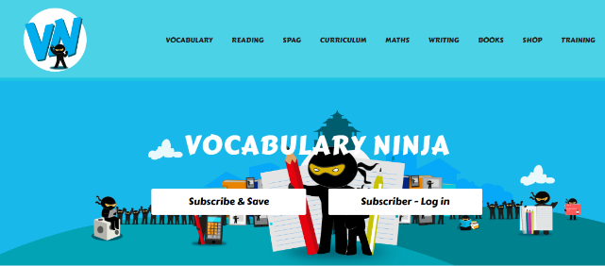
Vocabulary Ninja

https://vocabularyninja.co.uk/

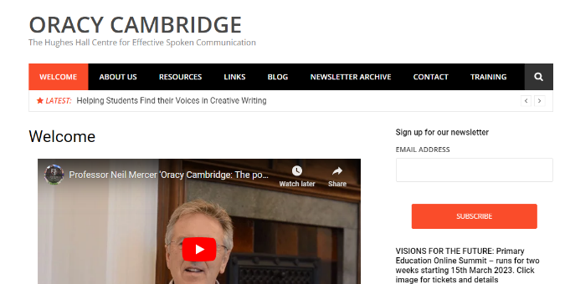
ORACY CAMBRIDGE
The Hughes Hall Centre for Effective Spoken Communication
https://oracycambridge.org/

